LINUX Installation

Step 1 : Visit https://www.virtualbox.org/wiki/Downloads to download Virtual Box Manager.
Step 2 : Now click on Windows Hosts (Bordered in the Red Section) , This will start Downloading your Virtual Box Manager.
Step 3 : Install Virtual box in your PC using the downloaded file.
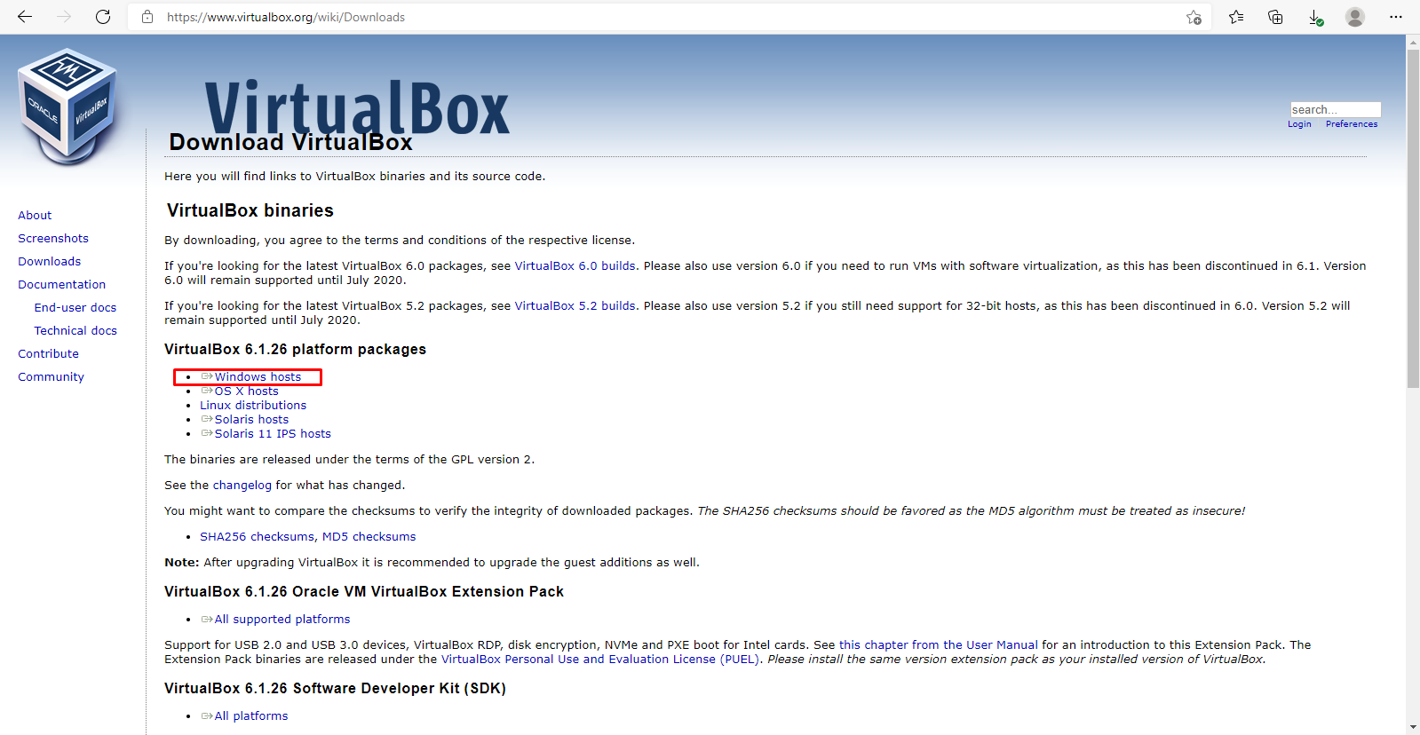

Step 3 : Download your Ubuntu/Linux files from the WEB.
For Linux visit Get Kali | Kali Linux
For Ubuntu visit Download Ubuntu Desktop | Download | Ubuntu
Step 5 : After Downloading both the above files, Open your Virtual box manager,
Now click on File on top left and then Click on Import Appliance
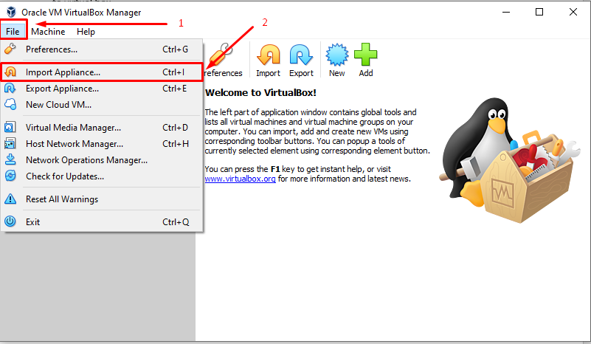
Step 6 : You will see a Similar screen , Click on the Folder icon on the right (RED BOX in the image)
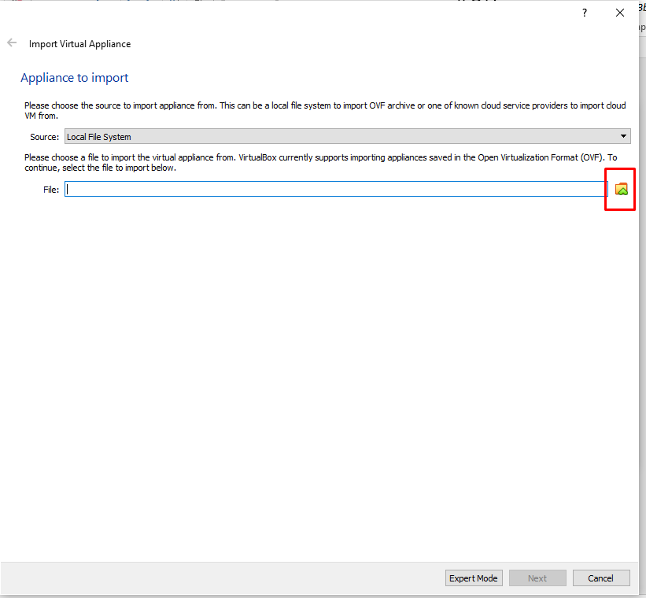
Step 7 : Browse to the location where you have downloaded the file from STEP 4.
And Click Open and then Click Next
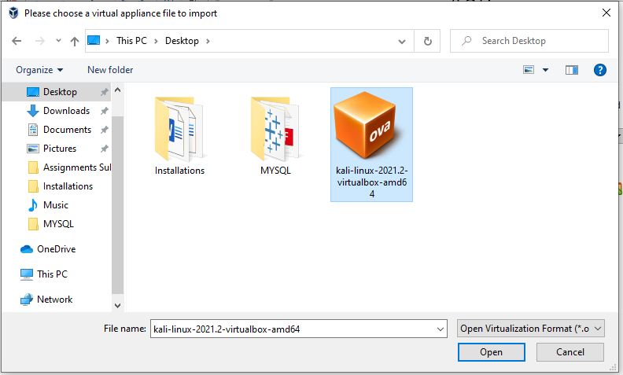
Next ,
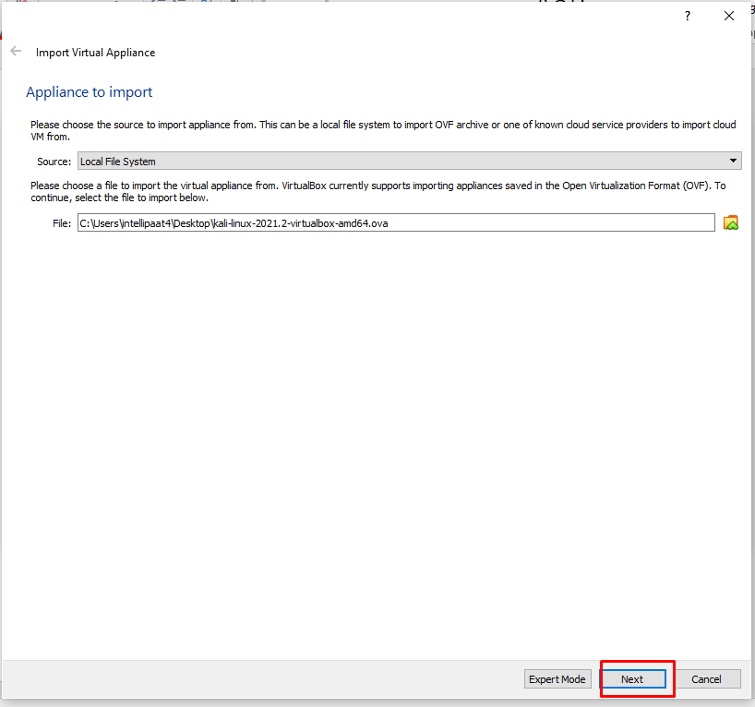

Step 8 : Click on Import and then Agree to terms and conditions.
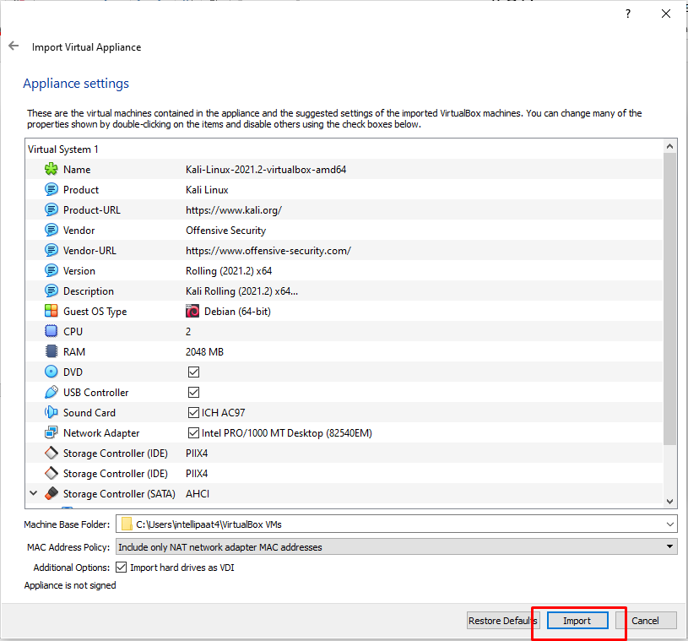
After you Click on Agree,
The System will start the Importing Process,
NOTE : This might take up to 10 -15 mins depending on your system.
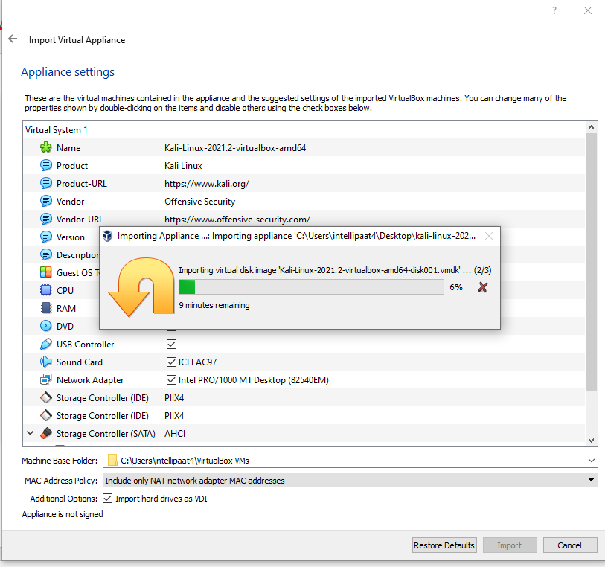
Step 9 : Once the importing process is complete, you will see a similar screen and Now Click on Start.
Start Your System
The booting process may take upto 5 minutes,
Use Credentials for Login
Username – kali
Password – kali

NOTE : If you receive error related to USB controller, Kindly select your VM machine , Click on settings and then Click on USB and disable the check box
Refer image below :
